Name: IYAKAREMYE Jean D’amour
Email:sachiox17@gmai.com
Reg:21RP04692
Stream A
Title: Automatic Temperature Variation control using Fan and heater
Abstract : Around world at least 75% of Smart room,Laboratories,stock,public place ,even in artificial intelligence use fan as temperature control for reducing coolness.My project will use Automatic Fan and Heater as temperature variation control . If temperature varying below 31 ⁰C the heater will be Automatically on for cooling to prevent coldness .If temperature is varying above 30 ⁰C Fan will be automatically on for reducing coolness.
Component required:Arduino(UNO),Relays(SRD-05VDC-SL-C),Fan(12V DC),Heater(220V AC)Temperature sensor(LM35).

Introduction

At smart room,public places,Laboratories and other place where temperature variation
Is a must, there were used to have Fan for reducing coolness by manually .for this case we select This system(Automatic Temperature Variation control using using Fan and Heater) which will prevent damage caused by temperature variation that will make good health of product(stock application),Laboratory’s chemicals,smart rooms and other artificial intelligence activities(ex: electronic devices)

Back ground
According to previous Systems,there were many method used to handle cooling problem by using fan which was also operated manually sometimes automatic.the operation of previous system were to turn on fan manually if high temperature occur.and other automatic fan were found in artificial intelligence such as desktop computer,laptop and other electronic devices.my project of temperature variation control will also use some of previous automatic system but will have additional features like heater which will be used when temperature vary below level we want to be on.this will help much because it have many option for where it should be applicable and for purpose the user may want according to temperature variation control.

The lack of temperature variation control can cause a variety of problems depending on the specific context. Here are a few examples:

1.Food storage: In commercial or home food storage settings, failure to control temperature variations can lead to spoilage of food, bacterial growth, and potential health hazards for consumers.

2.Manufacturing: In manufacturing processes that require precise temperature control, such as semiconductor fabrication or pharmaceutical production, lack of temperature variation control can lead to defective products and loss of revenue.

3.Environmental control: In settings where temperature control is critical for maintaining a comfortable or safe environment, such as hospitals or data centers, lack of temperature variation control can lead to discomfort, equipment failure, or even health hazards for occupants.

4.Agriculture: Lack of temperature variation control in agricultural settings, such as greenhouses or animal housing, can lead to poor crop yields, decreased animal health and productivity, and increased energy costs.

Overall, lack of temperature variation control can lead to a range of negative outcomes, including health hazards, product defects, decreased productivity, and increased energy costs. It is important to implement proper temperature control measures in relevant settings to avoid these issues.

Problem to be solved:

There were problems of controlling temperature because previous system were deal a lot
With coolness but coldness is also obstacle according purpose of system user.This system will
make constant temperature which can be used in agricultural project,public place,electronic device,stores of medical product,laboratory’s chemical,industrial application.

Temperature variation control can solve a wide range of problems, depending on the specific application and context. Here are some examples:

1.Energy Efficiency: In buildings, temperature variation control can help to save energy by maintaining a comfortable temperature while reducing heating and cooling costs.

2.Food Preservation: In food storage and transportation, temperature control can prevent spoilage and ensure the freshness of perishable goods.

3.Industrial Processes: In manufacturing and industrial processes, precise temperature control is necessary to ensure consistent product quality and improve efficiency.

4.Medical Applications: In medical applications, temperature control is critical for maintaining the safety and efficacy of pharmaceuticals, as well as for patient comfort during medical procedures.

5.Climate Control: Temperature control is essential in maintaining suitable conditions for plant growth in greenhouses and for animal husbandry in livestock buildings.

Overall, temperature variation control is a vital tool in many industries and applications, helping to maintain optimal conditions for a variety of processes and activities.

Ciruit diagram of Automatic temperature variation control
COMPONENT USED:
- ARDUINO UNO BOARD
- BREAD BOARD
- RELAY(SRD-05VDC-SL-C)
- HEATER(220V AC)
- FAN(12V DC)
- JUMP & WIRES

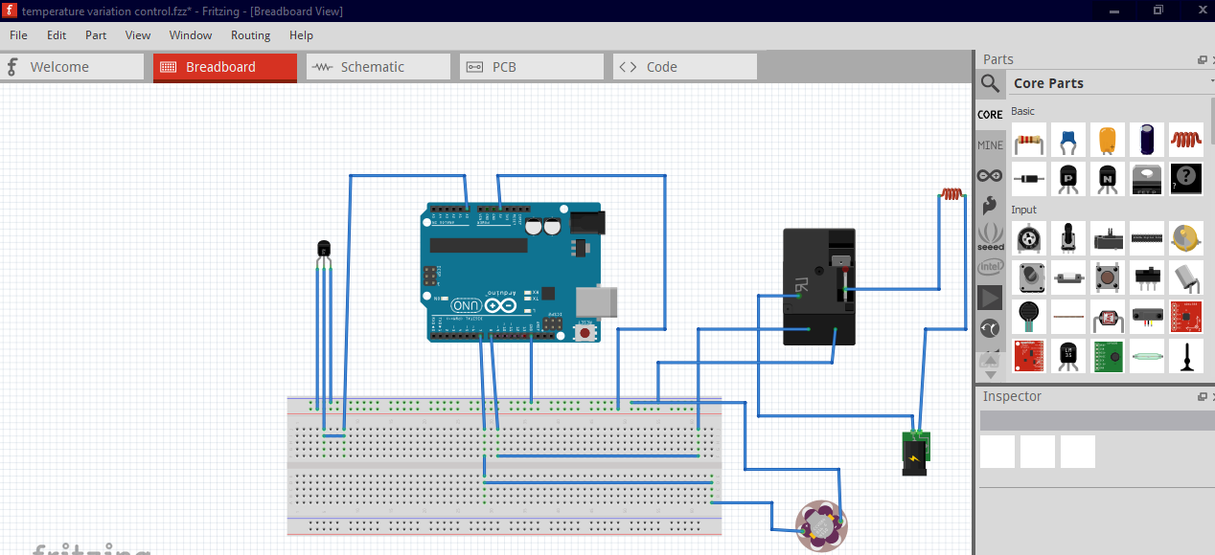

SOURCE CODE

int sensor=A0; //sensor is connected to A0 analog pin
int fan=8;// fan is connected to 8 digital pin
int relay=7;// relay IN pin connected to 7 digital pin
void setup() {
pinMode(sensor,INPUT);
pinMode(fan,OUTPUT);
pinMode(relay,OUTPUT);
Serial.begin(9600);
}

void loop() {
// measure the temperature and store it in a variable called "temp"

int temp = analogRead(A0); // assuming the temperature sensor is connected to analog pin A0
// convert the analog reading to voltage
float voltage = temp * 5.0 / 1023.0;
// convert the voltage to temperature in degrees Celsius
float celsius = (voltage - 0.5) * 100.0;
// display the temperature on the Serial monitor
Serial.print("\n");
Serial.print("TEMPERATURE=");// print the text "Temperature:"
Serial.print(celsius);// print the temperature in degrees Celsius
Serial.print("*C");// print the unit "C" for Celsius

if(celsius>30)
{
digitalWrite(fan,HIGH);//fan will be ON if temperature vary above 25 deg cel
digitalWrite(relay,LOW);// relay IN pin LOW
}
else
{
digitalWrite(fan,LOW);//fan will be OFF if temperature is equal or below 25 deg cel
digitalWrite(relay,HIGH);// relay IN pin will give signal which will connect COM and NO to turn ON heater
}
}

Working Principle
This system above as shown at diagram above ,This temperature sensor LM35 convert the voltage into degree in such way that 1 millivolt correspond to 0.1 degree celicius so 1 degree correspond to 10 millivolt,LM 35 sense temperature and provide analog signal which will be obtained at A0 of Arduino analog pin.According to front view of LM 35 the left terminal is connected to 5V supply of Arduino,right terminal is connected to ground of Arduino and terminal between them is output that will be connected to A0 Arduino analog pin.According to diagram shown above Fan is connected to 11 of Arduino digital pin,Relay coil(1)is connect to 13 of Arduino digital pin,Relay coil(2) is connected to ground of Arduino.The main contact of relay is connected with phase from supply(220V),Normal open of relay connected is to heater one terminal.
If coil of relay is energized main contact will have connection with Normal open,this will led to current to pass through main contact to normal open to heater start cooling, this occur if temperature vary below 31 degree celicius according to source codes.
When temperature vary above 30 degree celicius Fan will be ON and heater will be OFF.
Temperature variation control involves adjusting the temperature of a system to maintain a desired level. The operation of temperature variation control typically involves the following steps:

1.Measurement: The temperature of the system is measured using a temperature sensor.

2.Comparison: The measured temperature is compared to the desired temperature set-point.

3.Calculation: Based on the difference between the measured temperature and the set-point, a control algorithm calculates the amount of heating or cooling needed to maintain the set-point.

4.Action: The control algorithm sends a signal to the heating or cooling system to adjust its output, either by turning on or off, or by modulating its output.

5.Feedback: The control system continually monitors the temperature and adjusts the heating or cooling output as needed to maintain the set-point.

6.Tuning: The control system may need to be tuned to ensure that it responds appropriately to changes in the system and maintains the desired temperature with minimal overshoot or oscillation.

Overall, the goal of temperature variation control is to maintain a consistent and stable temperature within a system, which can be critical for processes such as chemical reactions, industrial manufacturing, and HVAC systems in buildings.
general objective of temperature variation control

GENERAL OBJECTIVES
The general objective of temperature variation control is to maintain a desired temperature range in a given environment or system. Temperature control is important in many fields, including manufacturing, agriculture, medicine, and environmental monitoring, among others.

The control of temperature is often necessary to ensure optimal conditions for the growth and development of organisms, the proper functioning of machinery and equipment, the preservation of food and other perishable items, and the safety and comfort of human beings.

To achieve this objective, various techniques and technologies can be used, such as thermostats, heating and cooling systems, insulation, ventilation, and feedback control mechanisms. The specific methods used will depend on the particular application and the desired level of precision and control.
specific objective of temperature variation control

SPECIFIC OBJECTIVE
The specific objective of temperature variation control depends on the context in which it is used. In general, temperature variation control is implemented to achieve one or more of the following objectives:

1.Process Control: Temperature control is essential in many industrial processes, such as chemical manufacturing, food processing, and HVAC systems. Maintaining a consistent temperature is necessary to ensure product quality, safety, and efficient production.

2.Energy Efficiency: Temperature control can help reduce energy consumption and costs by regulating the temperature of a system to the desired level. This is particularly important in buildings, where HVAC systems are responsible for a large portion of energy usage.

3.Comfort: Temperature control is also important for maintaining a comfortable indoor environment. In homes and commercial buildings, HVAC systems are used to regulate the temperature and humidity to ensure occupant comfort and health.

4.Equipment Protection: Temperature control is necessary to protect sensitive equipment, such as electronics, from damage due to temperature extremes.

5.Experimentation: Temperature control is essential in scientific experiments, especially in the fields of chemistry, biology, and materials science, where precise temperature control is necessary to obtain accurate results.

In summary, the specific objective of temperature variation control depends on the context in which it is used, but it generally involves maintaining a desired temperature range to achieve process control, energy efficiency, comfort, equipment protection, or experimental accuracy.
Budget for Project implementation.

The referrals on temperature variation control:

1.The Control of Temperature by R. E. Kalman and R. S. Bucy: This classic paper outlines the principles of feedback control and their application to temperature regulation. It covers both theory and practical considerations.

2.Temperature Control Handbook by A. C. Smith: This book provides a comprehensive overview of temperature control, including basic principles, practical applications, and case studies. It covers a wide range of topics, including instrumentation, sensors, controllers, and optimization.

3.Temperature Control in Pharmaceutical Manufacturing by S. P. Bhatia and B. S. Chakraborty: This book focuses on the specific challenges of temperature control in the pharmaceutical industry, including regulatory compliance, validation, and documentation. It covers both theory and practice, with case studies and examples.

4.PID Controllers: Theory, Design, and Tuning by T. E. Marlin: This book provides a detailed treatment of proportional-integral-derivative (PID) controllers, which are widely used in temperature control applications. It covers both theory and practice, with emphasis on design and tuning.

5.Advances in Temperature Control of Heating Processes by A. K. Bakhshi and S. K. Singh: This book focuses on temperature control in heating processes, such as furnaces, boilers, and kilns. It covers both traditional and advanced control techniques, including fuzzy logic and neural networks.

6.Temperature Control in Food Processing by J. F. Kennedy: This book provides a detailed overview of temperature control in the food industry, including processing, storage, and transportation. It covers both theory and practice, with case studies and examples.

7.Temperature Control in Laser Diode Systems by J. M. Vasilescu and J. D. Rogers: This paper focuses on temperature control in laser diode systems, which are used in a wide range of applications, including telecommunications, medicine, and scientific research. It covers both theory and practice, with emphasis on thermal management and control.

These referrals cover a range of temperature control topics, from basic principles to specific applications. They should provide a good starting point for further research.

